Congratulations on participating in the online version of the SCOPE of Leadership development program. In this program you will learn the competencies consistently found in great leaders who deliver results and lead as coaches.

This program includes six courses. Each course includes several modules and each module includes topics and discussion questions:

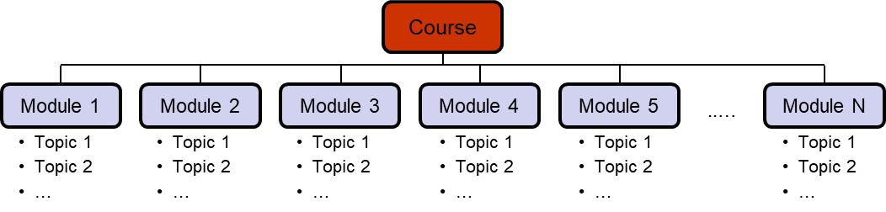

As you get started with Course One, Leadership Competencies that Enable Results, here are a few tips to guide your journey:

Steps to get started:
- Go to https://alpinelink.com/scope-of-leadership-courses/ to login.
- Login using your assigned username and password.
That’s it. You are now enrolled and ready to start your learning journey.

As you complete the modules and their topics, you will encounter typical learning system terms. Here are their definitions:

Navigation definitions:
- Materials: Online resources related to the course, module, or topic
- Hint: Provides help in answering a question
- Check: Closes out a question and provides feedback
- Essay Upload Success: Verifies your homework was successfully received
- Next: Presents the next question
- Finish Discussion: Closes out a set of questions, records your results, and takes you to the next screen
- Restart Discussion: Takes you back to the beginning of a topic
- Mark Complete: Records that you have completed a topic or module and takes you to the next one, or if on the last topic takes you back to the module introduction

If you have any questions or need support, email Randy Emelo at randy@alpinelink.com.

