Communicating is what most of us do more than any other activity. Our ability to communicate therefore determines our success in relationships and getting things done—personally and professionally. Virtually everything we strive to achieve is impacted by how well we communicate.

Use this assessment to rate yourself, or others, on common communication annoyances that prevent people from being the best communicators they can be. Some of these annoyances reflect external communication styles. Others go deeper and reflect how people express their inner thoughts and motives.

To check for communication blind spots, have others complete this assessment based on their perceptions of you and compare how you rate yourself to how they rate you.

Person for whom this assessment applies: _________________________________________________

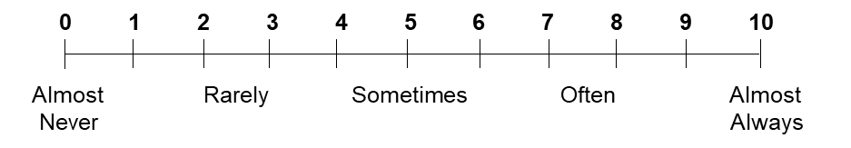

Use this scoring scale to rate each area:

Place a check mark in the left column for any areas rated above a 7 to identify areas most in need of attention.

 | Communication Annoyances | Score | Comments
 | Inattentive:
 | - Asks others to repeat what was said
 | - Isn’t engaged or mentally present, emotionally disconnected, distracted
 | - Diverts eye-contact such as when people walk by
 | Self-Centered:
 | - Boasts, takes credit, strives to be the center of attention
 | - Does most of the talking, talks for too long
 | - Doesn’t listen, doesn’t show empathy, doesn’t make people feel heard or valued
 | - Doesn’t check for understanding, doesn’t invite others to ask questions
 | - Doesn’t ask questions, doesn’t show interest in others
 | - Interrupts, talks over people, doesn’t let others finish what they are saying
 | - Uses words to appear smart or knowledgeable
 | Avoidant:
 | - Isn’t open to feedback or others’ opinions
 | - Shuts down, stops talking
 | - Justifies, defends, deflects, or doesn’t take responsibility
 | Controlling:
 | - Withholds information, doesn’t keep people informed, or assumes people know more than they do
 | - Controls what others say or manages others’ communication for them
 | - Strives to convince, pressure, prove, or force others to think, accept, or do something
 | - Tells people what to do, demands, or attempts to control what people do
 | Discreditable:
 | - Exaggerates, lies, or hides the truth
 | - Complains, has a negative perspective
 | - Talks mostly about others, gossips, disparages others
 | - States opinions as facts
 | Unkind:
 | - Threatens, manipulates, or uses passive-aggressive language
 | - Admonishes, belittles, accuses, blames, bullies, lectures, or attacks, especially in front of others
 | - Projects shortcomings on others, gaslights
 | - Talks overly candidly, is very direct
 | - Talks down to people, is condescending
 | - Uses sarcasm, ridicules, or mocks others
 | Confusing:
 | - Doesn’t speak clearly, isn’t easily understandable, has a strong accent, or lacks fluency in language
 | - Lacks flow, transitions unexpectedly, changes topics, or confuses by backing up or jumping ahead
 | - Doesn’t articulate the “why” or the big picture, or doesn’t provide sufficient background information
 | - Changes narrative, is inconsistent in message
 | Insignificant:
 | - Repeats content or rambles on
 | - Provides not enough detail or content is too simple
 | - Provides too much detail or content is too complex
 | - Talks meekly and timidly, is overly empathetic, uses overly passive language, or is too self-deprecating
 | - Talks too soft, hard to hear
 | - Talks too fast
 | - Talks too slow
 | - Lacks energy or enthusiasm
 | - Lacks personalization, rote
 | - Talks mostly about the past such as past conversations and events
 | - Judges, applies own values against others
 | - Uses unnecessary words, or filler superfluous words like “uh” or “you know”
 | Too Emotional:
 | - Shows too much concern or empathy
 | - Talks too loud or yells
 | - Displays too much emotion or passion
 | - Doesn’t appeal to people’s logic
 | - Too Logical:
 | - Doesn’t appeal to people’s emotions
 | - Gives advice when not appropriate or requested
 | Inappropriate:
 | - Uses profanity, poor grammar, poor spelling, too much jargon, or poor word choice
 | - Uses insenstive humor or tasteless jokes
 | - Uses language that is racist or culturally insensitive
 | - Is too formal
 | - Is too informal
 | - Gets too close to people when talking, ignores social distance norms
 | - Is too transparent, shares private, confidential, or overly personal information
 | - Uses the wrong channel of communication, like email or text, or less than ideal time or location for the purpose intended
 | Distracting:
 | - Talks with food in mouth
 | - Is nervous, seems uncomfortable
 | - Uses distracting or inappropriate hand gestures
 | - Laughs or smiles too much
 | - Nods in agreement too much, overly agreeable
 | - Uses odd or distracting facial expressions
 | Other:
 | - Other:
 | - Other:

