[your name]
Goal Setting Worksheet

Last updated: [date]

List the key goals below in which you will focus to achieve your aspirations including your long-term dreams as well as short-term performance expectations.

Business Objectives and Goals
List your current individual or shared organizational business objectives including operational, financial, and other KPIs. Examples of goals include: $125M in revenue, 13% net profit, 15% year-over-year growth, 75% client satisfaction, 80% employee engagement, zero safety incidents.

Professional Development Goals
List your professional self-development goals that will enable achievement of your business objectives and career aspirations including leveraging your strengths, developing in your weaker areas, and overcoming your fears. Examples of goals include: “Learn to motivate my team”, “Improve my presentation skills”, “Finish my degree or certification”, “Become a great coach to my team”, “Deepen my financial management knowledge”, or “Be an effective delegator”.

Personal Development Goals
List your personal vision, mission, dreams, and/or goals here. This could include goals in any area of your life as shown in this diagram. Consider your life as a whole, i.e. all the areas in which you have dreams, aspirations, and goals.

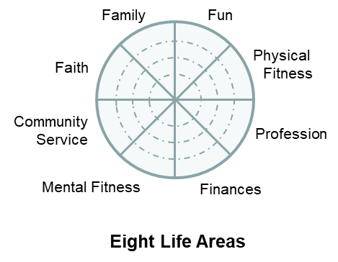
Using the table below, list the areas in which you have goals in the “life area” column. For each life area, list your key goals in the “goal” column. They can be short-term, medium-term, or long-term. Next, list the enabling development you plan to pursue for each. In other words, identify the areas of knowledge, skill, thinking, or behavior change you need in order to achieve your goals.

Goal examples include: “Improve my physical fitness”, “Save money for my kid’s college”, “Spend more time with family”, “Join a volunteer board in my community”, “Lead a faith-based study group”, “Build a new house”

Enabling development examples include: “Spend 30 minutes in cardio activity three times a week”, “Eat a salad every day for lunch”, “Put $400 a month into savings”, “Spend an hour each evening in reflection, meditation”.

 | Life Area | Goal | Enabling Development

